**SPRINT-1**

| Team ID | PNT2022TMID04174 |
| --- | --- |
| Project Name | Project **- Industry-Specific**  **Intelligent Fire Management**  **System** |

**CODE FOR ARDUINO**

#include <OneWire.h>

#include <DallasTemperature.h>

#define ONE_WIRE_BUS 5

OneWire oneWire(ONE_WIRE_BUS);

DallasTemperature sensors(&oneWire);

float Celcius=0;

float Fahrenheit=0;

float voltage=0;

const int analogInPin = A0;

int sensorValue = 0;

unsigned long int avgValue;

float b;

int buf[10],temp;

void setup(void)

{

Serial.begin(9600);

sensors.begin();

int sensorValue = analogRead(A1);

voltage = sensorValue * (5.0 / 1024.0);

}

void loop(void)

{

sensors.requestTemperatures();

Celcius=sensors.getTempCByIndex(0); Fahrenheit=sensors.toFahrenheit(Celcius); for(int i=0;i<10;i++)

{

buf[i]=analogRead(analogInPin); delay(10);

}

for(int i=0;i<9;i++)

{

for(int j=i+1;j<10;j++)

{

if(buf[i]>buf[j])

{

temp=buf[i];

buf[i]=buf[j];

buf[j]=temp;

}

}

}

for(int i=2;i<8;i++)

avgValue+=buf[i];

float pHVol=(float)avgValue*5.0/1024/6; float phValue = -5.70 * pHVol + 21.34;

Serial.println(phValue);

Serial.print("pH");

Serial.print(" C ");

Serial.print(Celcius);

Serial.print(voltage);

Serial.print("V");

delay(10000);

}

**CODE IMPLEMENTATION**

import serial

import time

import csv

import numpy as np

import matplotlib.pyplot as plt

ser = serial.Serial('/COM6',9600)

ser_bytes = ser.readline(10)

print (ser_bytes)

ser.flushInput()

while True:

try:

ser_bytes = ser.readline()

decoded_bytes = float(ser_bytes[0:len(ser_bytes)-2].decode("utf-8")) print(decoded_bytes)

temp = float(decoded_bytes(1:3))

turb = float(decoded_bytes(4:6))

pH = float(decoded_bytes(6:8))

with open("test_data.csv","a") as f: writer = csv.writer(f,delimiter=",") writer.writerow([time.time(),decoded_bytes]) except:

print("Keyboard Interrupt")

ser.close()

break()

t = np.arange(0.0, 2.0, 0.01)

s = 1 + np.sin(2*np.pi*t)

plt.plot(t, s)

plt.xlabel('time (s)')

plt.ylabel('Celsisus (C)')

plt.title('Temperature')

plt.grid(True)

plt.savefig("Temperature.png")

plt.show()

Serial.begin(9600);

sensors.begin();

int sensorValue = analogRead(A1); voltage = sensorValue * (5.0 / 1024.0); }

void loop(void)

{

sensors.requestTemperatures();

Celcius=sensors.getTempCByIndex(0);

Fahrenheit=sensors.toFahrenheit(Celcius); for(int i=0;i<10;i++)

{

buf[i]=analogRead(analogInPin);

delay(10);

}

for(int i=0;i<9;i++)

{

for(int j=i+1;j<10;j++)

{

if(buf[i]>buf[j])

{

temp=buf[i];

buf[i]=buf[j];

buf[j]=temp;

}

n = 256

X = np.linspace(-np.pi, np.pi, 256, endpoint=True) C,S = np.cos(X), np.sin(X)

plt.plot(X, C)

plt.plot(X,S)

plt.show()

print ("Visualization of real time sensor Data.") print("/n")

while True:

try:

ser_bytes = ser.readline()

decoded_bytes = float(ser_bytes[0:len(ser_bytes)-2].decode("utf-8")) print(decoded_bytes)

temp = float(decoded_bytes(1:3))

turb = float(decoded_bytes(4:6))

pH = float(decoded_bytes(6:8))

with open("test_data.csv","a") as f:

writer = csv.writer(f,delimiter=",")

writer.writerow([time.time(),decoded_bytes])

except:

print("Keyboard Interrupt")

ser.close()

break()

t = np.arange(0.0, 2.0, 0.01)

s = 1 + np.sin(2*np.pi*t)

plt.plot(t, s)

**OUTPUT:**

**TEST CASE 1:**

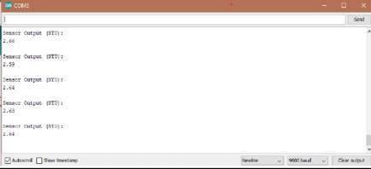

**TEST CASE 2:**

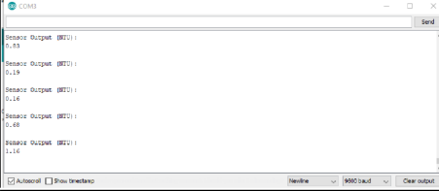**FINAL OUTPUT:**

